Project Title

Personal Budgeting & Expense Forecaster

Project Statement
Managing personal finances is a major challenge for many individuals. People often struggle to:
- Track daily expenses
- Maintain a monthly budget
- Predict future spending
- Identify unnecessary spending areas
- Achieve long-term financial goals
Traditional budgeting is manual, time-consuming, and prone to errors. Also, predicting future spending patterns without analytics is extremely difficult.
This project solves these challenges by building a smart, AI-enabled Personal Budgeting & Expense Forecasting Tool.

The system will do :
- Tracks transactions (income & expenses)
- Categorizes them automatically using rule-based/NLP methods
- Analyzes spending patterns
- Forecasts future expenses using Prophet (Meta/Facebook forecasting tool)
- Helps users set and track financial goals
- Shows dashboards and charts to understand finances clearly
- Offers admin tools for category management
- The goal is to help users make data-driven financial decisions, reduce overspending, and improve financial health

Outcomes of the Project

Clear Financial Overview
- Income, expenses, savings summaries
- Full transaction dashboard

AI-Powered Expense Forecasting
- Predict future monthly/weekly spending
- Identify spikes or unusual changes

Spending Pattern Identification
- Categorized spending
- Most expensive categories
- Monthly comparison

Goal-Oriented Planning
- Create financial goals
- Track forecast-based progress
- Alerts for overspending

Data Insights
- Expense anomalies
- Seasonal spending patterns
- Trend analysis

User-Friendly Interface
- Streamlit-based interactive dashboard
- CSV upload/import
- Simple and intuitive workflows

Modules Implemented
Below are all modules included in your final project.

Module 1: User Authentication & Profile Management

Features
- User Registration (email, password, full name)
- Secure Login (JWT token-based)
- Session state management in Streamlit
- User profile tracking

Backend Implementation
- FastAPI backend
- SQLite database
- JWT authentication
- Password hashing (bcrypt)

Packages Used
- FastAPI
- python-jose / PyJWT
- SQLite / SQLAlchemy
- Streamlit session_state
- Requests

Module 2: Transaction Ingestion & Categorization

Features
- Manual transaction entry
(date, description, amount, type: income/expense)
- CSV file upload
- Automatic categorization using:
- Rule-based mapping
- NLTK keyword detection
- Category override support

Backend
- Transaction DB table
- API to add, fetch, bulk upload

Packages Used
- NLTK (word tokenization, keyword match)
- Pandas (CSV parsing, cleanup)
- FastAPI file uploads
- NumPy

Module 3: Data Analysis & Reporting

Features
- Category-wise spending summary
- Monthly income vs. expense
- Pie charts, line charts
- Custom time period filters

Packages Used
- Pandas (groupby, aggregations)
- Matplotlib
- Seaborn

Reports Generated
- Total spending per category
- Monthly trend reports
- Income vs Expense comparison
- Top spending categories

Module 4: Forecasting Engine & Goal Setting

Forecasting Features
- Data preparation (monthly aggregation)
- Prophet model for predictions
- 3-month / 6-month forecasts
- Forecast visualization (trend + prediction intervals)
- Comparison with actuals

Goal Setting Features
- User sets financial goals
(e.g., Save $2000 in 3 months)
- ML-based estimation of goal achievement
- Progress tracking dashboard

Packages Used
- Prophet (from Meta)
- Pandas (time series formatting)
- NumPy (data reshaping)
- Matplotlib (forecast charts)

Module 5: Advanced Visualization & Interactive Dashboard

Features
- Category distribution
- Forecasted vs actual expenses
- Savings prediction
- Goal tracking charts
- Interactive Streamlit UI

Packages
- Streamlit
- Matplotlib / Seaborn
- Plotly (optional interactive graphs)

Module 6: Admin Dashboard

Features
- Category management
- Transactions monitoring
- User activity logs
- System data consistency check

Packages
- Streamlit
- Pandas
- FastAPI admin API

Week-Wise Milestones

Milestone 1 (Week 1–2) — Authentication + Basic Transactions

Deliverables
- Registration & Login
- JWT authentication
- Manual transaction input
- SQLite DB setup
- Basic UI in Streamlit

Output
✔ Users can login
✔ Users can add dummy expenses
✔ Basic interface is working

1.User Registration System
- Implemented a secure registration feature using FastAPI.
User enters:
- Full name
- Email
- Password
Passwords are stored securely using:
- bcrypt hashing via passlib
- New users are added into the User Database (SQLite).

2.Secure Login System
- Designed using JWT (JSON Web Tokens).
- When a user logs in:
Credentials are verified in the User DB
A JWT access token is generated
Streamlit stores token in session_state
- All subsequent requests to backend require:
Authorization: Bearer <token>

3.Session Management in Streamlit
- When a user logs in, the session stores:
Token
Email
- Sidebar shows “Signed in as: user@example.com”.
- Logout clears the session and reruns the app.

4.Basic Transaction Input UI
- Built a simple, clean Streamlit form:
    - Date
    - Amount
    - Type (income/expense)
    - Category (optional)
    - Description
- Form submits data via POST to backend /transactions endpoint.

5.Transaction Storage
- Stored in SQLite under the Transaction DB with fields:
    - ID
    - User ID
    - Date
    - Amount
    - Type
    - Category
    - Description
- Display Transactions to User
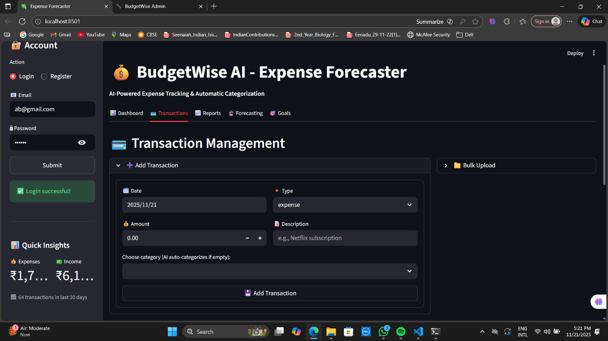

Milestone 2 (Week 3–4) — Categorization & Reporting

Deliverables
- Rule-based + NLP categorization
- Expense grouping by category
- Monthly income vs expense report
- Initial dashboard

Output
Pie chart: category-wise spending
Line graph: monthly trend
Automatic category tagging

1.Automated Transaction Categorization
Two methods implemented:

a) Rule-Based Categorization
- Created a mapping like:
Keyword | Category
“Uber” | Transport
“Swiggy”, “Zomato” | Food
“Electricity” | Utilities

b) NLP Categorization (NLTK)
- Tokenize description text using NLTK.
- Search for keywords in the token list.
- Assign best-matching category.

2.CSV Upload Support
- Users can upload a CSV file with:
    - date
    - amount
    - description
    - category (optional)
    - type
- Backend processes and stores each entry.

3.Basic Financial Reports
Built using Pandas groupby operations.

a) Spending by Category
- Sum of expenses per category.
- Displayed as:
  - Pie chart (non-negative data)
  - Bar chart (if negative refunds exist)

b) Monthly Income vs Expense
- Aggregated monthly totals.
- Plotted as a line chart.

4.Initial Dashboard Setup
- Shows:
  - Latest transactions
  - Category breakdown
  - Monthly trends
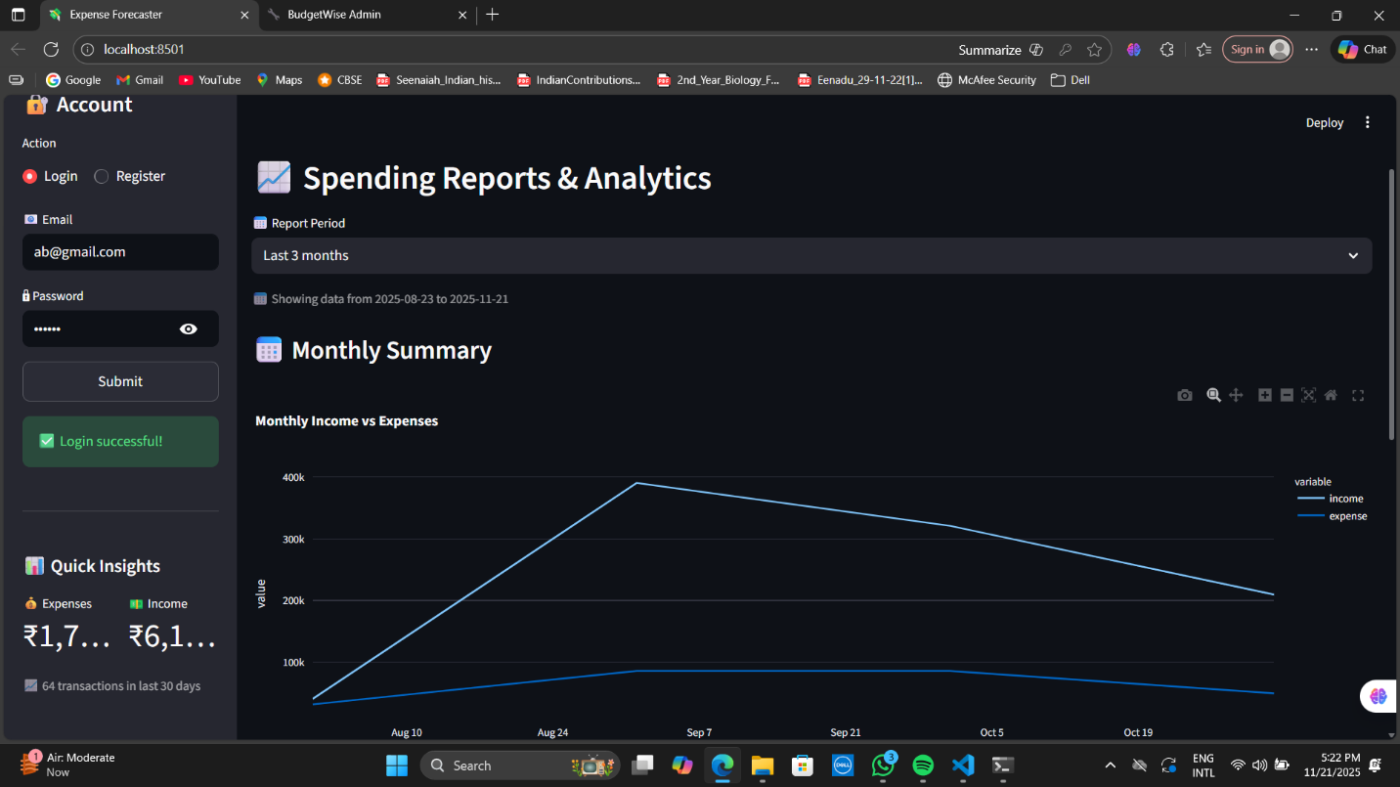
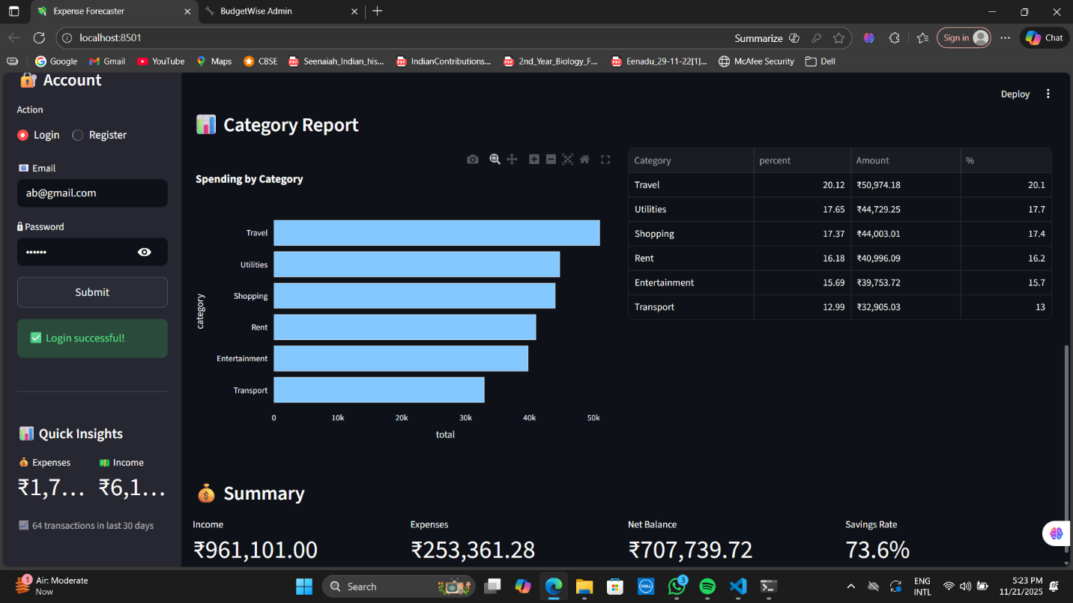

Milestone 3 (Week 5–6) — Forecasting + Goals

Deliverables
- Data cleaned for ML
- Prophet model integrated

1. Data Preparation for Forecasting
- Generate a clean time-series dataset:
  - Aggregate transactions by month
  - Ensure Prophet-friendly format

2. Prophet Forecasting Model Integration
- Used Prophet (Meta/Facebook) to forecast:
  - Next month’s total expenses
  - Category-wise predictions
  - Yearly seasonality patterns
- Steps:
- Fit Prophet model on historical data
- Generate future dataframe
- Predict values
- Plot forecasted curve + confidence intervals

3. Goal Setting Module
- User can create goals, such as:
  - “Save 5000 in next 3 months”
  - “Reduce grocery spending by 20%”
  - Stored in Goals DB.
- Streamlit UI displays:
  - Goal progress
  - Whether user is on track

4. Forecast Visualization
- Created powerful visualizations:
  - Actual vs predicted expenses
  - Confidence bands
  - Trend and seasonality graphs
  - Forecast-Based Insights

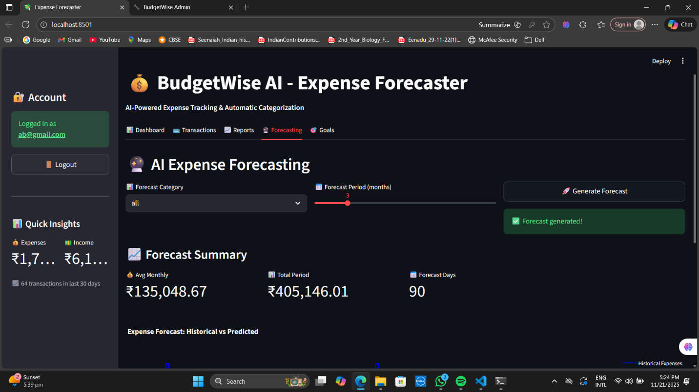
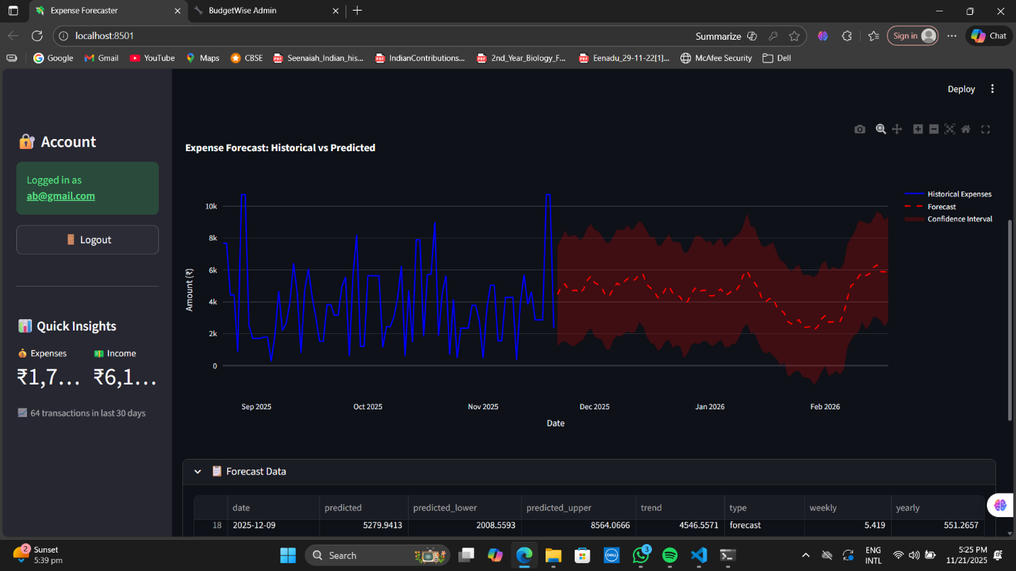
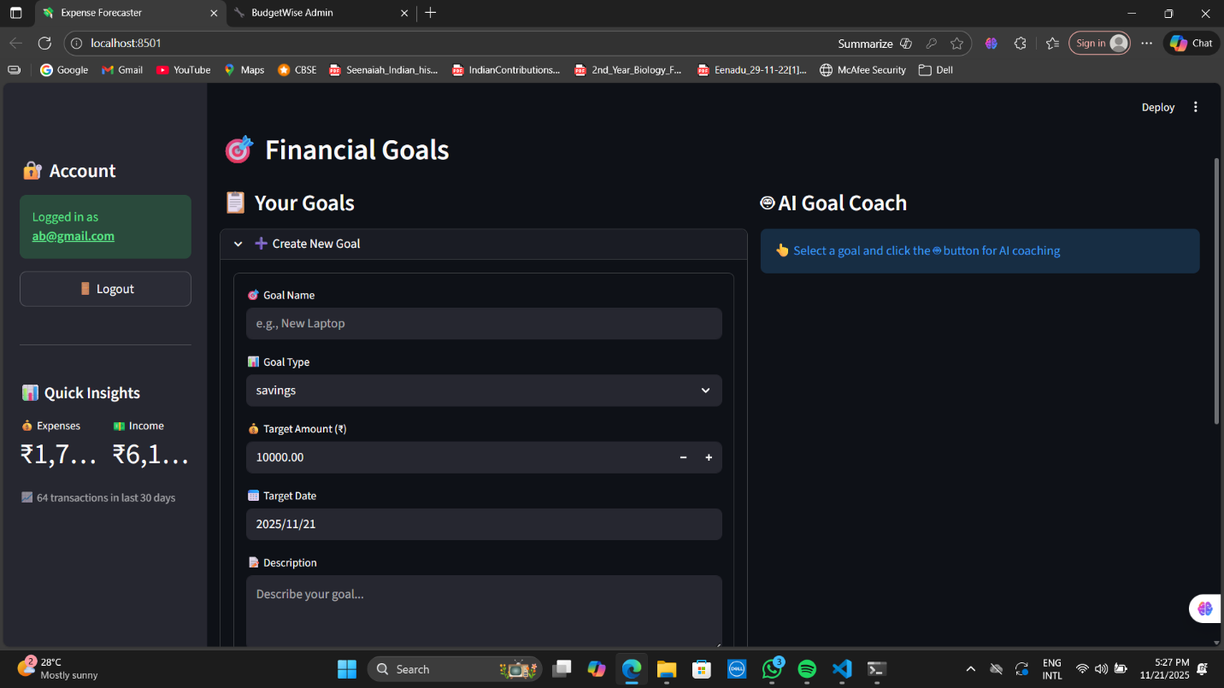

Milestone 4 (Week 7–8) — Dashboard + Admin

Deliverables
- Full interactive dashboard
- Admin panel
- Docker container
- Production-ready app
- Final documentation & presentation

Output
✔ Complete web app
✔ All modules integrated
✔ Ready for demo & deployment

1. Advanced Interactive Dashboard
- Integrated:
  - Category distribution (Pie/Bar)
  - Monthly cash flow chart
  - Forecasted vs actual chart
  - Goal progress meters
- Summary cards:
  - Total Income
  - Total Expenses
  - Savings
  - Highest-spend Category

2. Admin Panel
- Admin panel enables:
  - Category management
  - View all users / transactions
  - Fix incorrectly tagged categories
  - Manage NLP/rule sets (optional)

3. System Monitoring Tools
- API usage logs
- Storage usage
- Admin-only access via JWT role-based checks

4. Deployment Preparation
- Created Dockerfile
- Organized backend & frontend
- Prepared requirements.txt
- Verified running on:
  - Streamlit Cloud
  - Render
  - Local Docker

5. Documentation & Presentation Materials
- Project report
- PPT slides
- Architecture diagram
- Workflow diagrams
- Model evaluation results

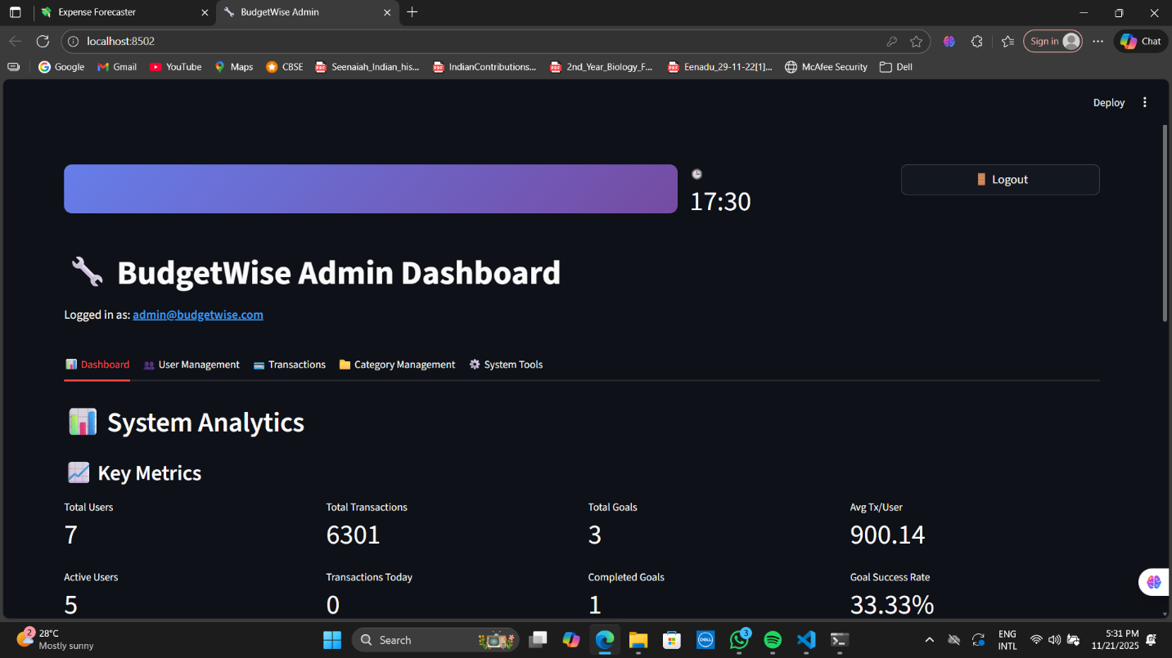
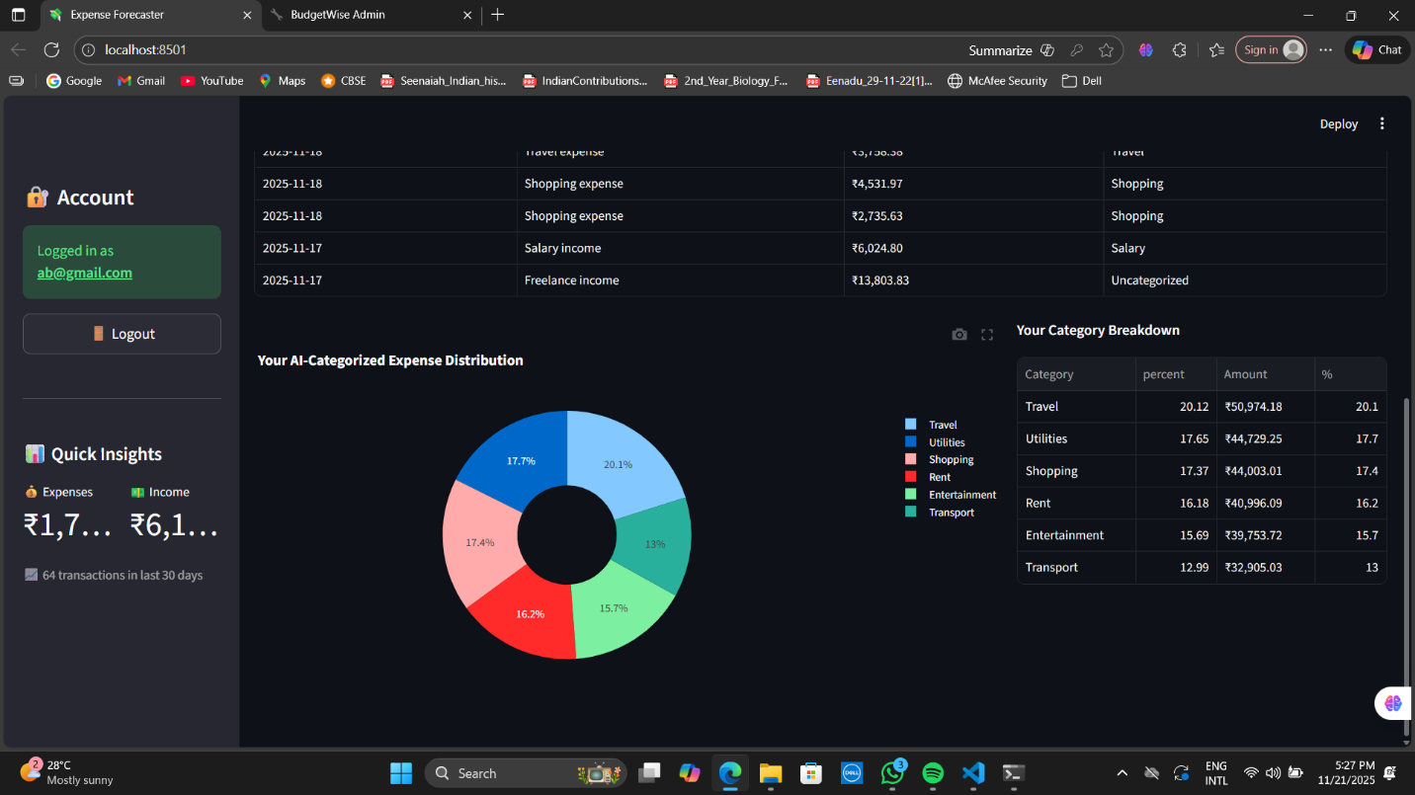

System Architecture Overview
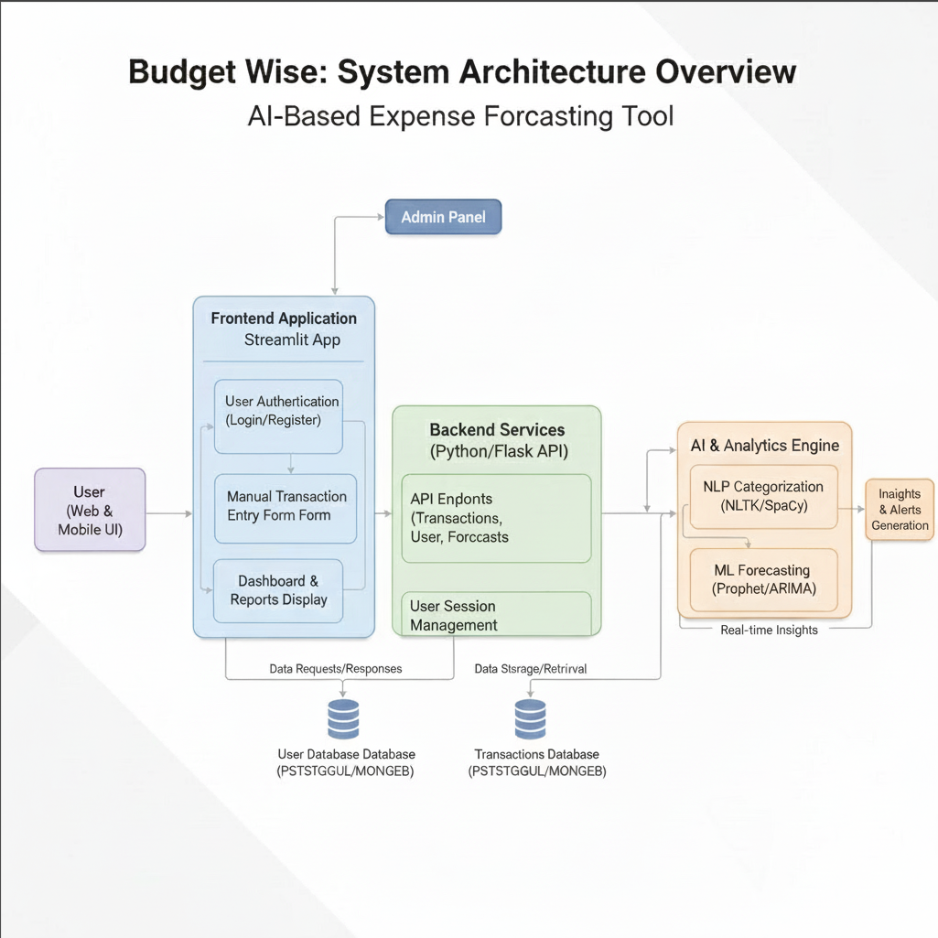

Packages Used (Complete List)

Backend (FastAPI)
- fastapi
- uvicorn
- python-jose / PyJWT
- passlib[bcrypt]
- sqlalchemy
- pydantic
- python-multipart
- Machine Learning / Forecasting
- prophet
- pandas
- numpy
- NLP (Categorization)
- nltk
- Visualization
- matplotlib
- seaborn
- (optional) plotly

Frontend (Streamlit)
- streamlit
- requests
- Database
- sqlite3
- sqlalchemy

Workflow (Content for Documentation)
Workflow Explanation
1. User
- Registers and logs in
- Inputs transactions manually or via CSV
- Views forecasts, goals, and reports
2. Web UI (Streamlit)
- Provides dashboard
- Sends/receives data using API
- Renders charts and insights
3. Backend (FastAPI)
Handles:
- Authentication
- Transaction storage
- Categorization
- Forecasting
- Goals
- Admin controls
4. Databases
- User DB: Stores user profile and login credentials
- Transaction DB: Stores all transaction data
- Goals DB: Stores user financial goals
5. Categorizer (NLTK / Rule-Based)
- Extracts keywords from transaction description
- Assigns category automatically
- Example: "Swiggy" → Food, "Uber" → Transport
6. Processing Layer (Pandas / NumPy)
- Performs grouping, aggregation
- Generates monthly summaries
- Cleans data for forecasting
7. Forecasting Engine (Prophet)
- Generates future predictions
- Computes seasonal patterns
- Outputs spending estimates
8. Admin Panel
- Manages categories
- Monitors system usage
- Handles data cleanup
9. Dashboard Output
- Category spending pie chart
- Monthly trend chart
- Forecasted vs actual expenses
- Goal progress
- Alerts & insights

Conclusion
The Personal Budgeting & Expense Forecaster is a complete end-to-end financial analytics system.
It integrates dashboards, NLP-based categorization, financial forecasting, and goal management into a single user-friendly platform.
This project demonstrates:
- Full-stack development
- Machine learning (Prophet forecasting)
- NLP categorization
- Data engineering
- Visualization
- Deployment
- Authentication & admin management

